A.O.K. Laptop System Overhaul

Course Project: IS 436 Structured Systems Analysis and Design

Deliverable 3 – “Process Modeling” (D3)

11/06/2019

Team Name: Meticulous Evolution Consulting

Project Sponsor: Library Services Manager, Paula Langley.

Presented By:

|  |  |  |
| --- | --- | --- |
| **NAME** | **POSITION** | **CONTACT** |
| Upen Adhikari | Quality Assurance | [Adh3@umbc.edu](mailto:Adh3@umbc.edu) |
| Omar Al-Hedari | Project Manager | [Omara2@umbc.edu](mailto:Omara2@umbc.edu) |
| Nima Roomi | Lead Developer/Programmer | [nimar1@umbc.edu](mailto:nimar1@umbc.edu) |
| Alex Varghese | Database Administrator | [varghes1@umbc.edu](mailto:varghes1@umbc.edu) |
| Ralu Ofoche | Systems Analyst | [rofoche1@umbc.edu](mailto:rofoche1@umbc.edu) |

Fig 1.0 : Context Diagram

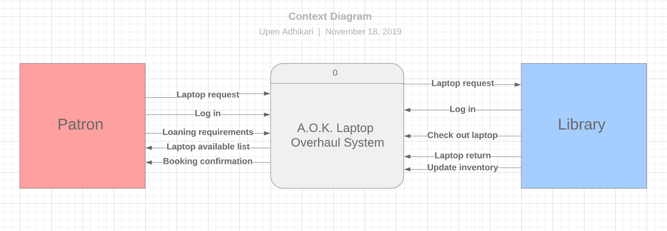

Fig 1.1 **Level 0 Diagram**

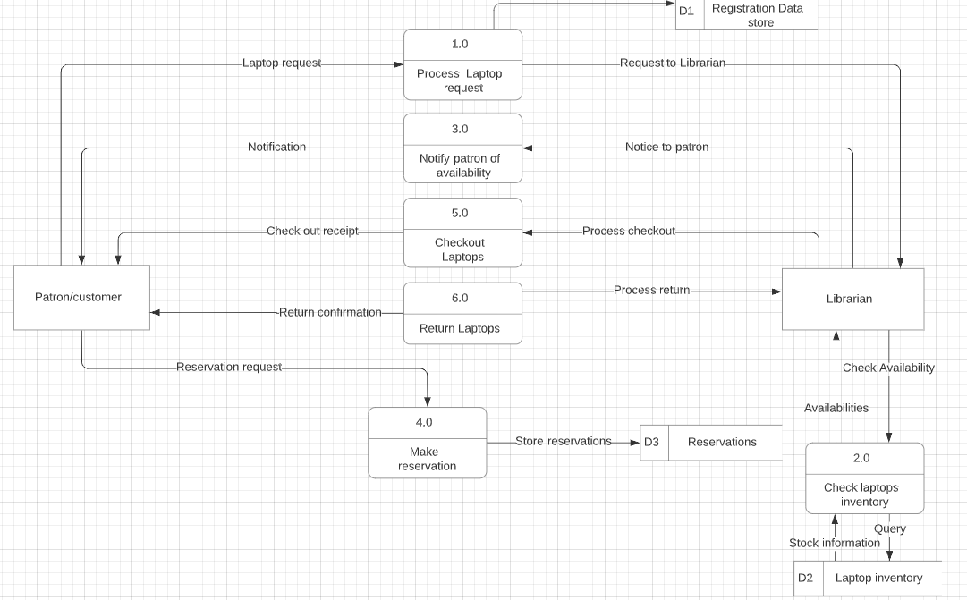

**Processes**

1. Process Laptop Request – This process represents how the customer will log in to the system and perform an online booking of a laptop depicting the time of reservation and return dates.
2. Check Laptops Inventory: – In this process, the librarian check the availability of the laptop.
3. Notify Patron of Availability: After querying the availability of laptops, the patron will be notified with the list of available laptops.
4. Make Reservations: The patron will make the reservations of laptop after viewing the list of available laptops. The reservation of the laptops will be stored in the database storage under reservations.
5. Check out Laptop – This process will be used to save the book details of the customer and the expected return date. The librarian will process the checkout and after the successful completion of the process the checkout receipt will be delivered to the patron.
6. Return Laptop – This process will be carried out by the librarian and will include filling out of a form that will be used to monitor the condition of a laptop when the customer returns it by comparing it with the data collected during picking of the laptop

**Data Flow**

* Laptop Request: The patron request the laptop.
* Request to Librarian: The request of the laptop by the patron will be accessed by the librarian.
* Check Availability: The librarian will check the availability of the laptops against the laptop inventory.
* Query: Check Laptop Inventory will be queried against the laptop inventory by the librarian.
* Stock Information: Laptop Inventory is providing the Inventory information to the librarian.
* Availabilities: The laptop availabilities will be forwarded to the librarian through the process of Check Laptops Inventory.
* Notice to Patron: The Librarian will provide the notice of availability of a laptop.
* Notification: The notification will be forwarded to the patron through the process of notifying the patron of availability.
* Reservation Request: The patron makes the reservation request.
* Store Reservation: The reservation made by the patron will be stored in the reservation database.
* Process Checkout: The librarian processes the checkout of the laptop.
* Check Out Receipt: After successful checkout, the check out receipt will be forwarded to the patron.
* Process Return: Librarian processes the return of the laptop.
* Return Confirmation: After the return is complete, the written confirmation will be forwarded to the patron.

**External Entities:**

**Patron/Customer:** The patron interacts for the whole processes of laptop requests.

**Librarian:** The librarian will receive the notification about the laptop request and processes the requests.

### Data Stores

**D1. Registration data store –** This data store keeps a record of the data of the customer that includes the name, address and billing information.

**D2. Laptop inventory–** This data store keeps data of the available laptop inventory.

**D3. Reservations –** This data store keeps details on the reservation history of every customer and created on the first reservation of the customer.

**Level 1 Diagram**

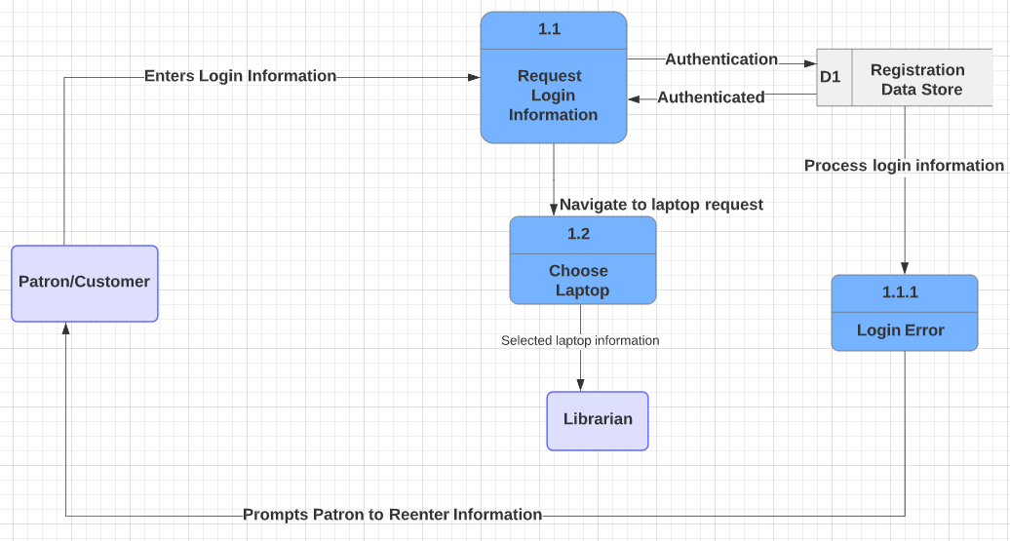

**Sub-Processes**

* 1. Request Login Information - In this process, when the patron processes the laptop request, he will be directed to the login page requesting username and password. The username and password will be verified against the data storage of student information. The system authenticates the user and provide access to the user.
     1. Login Error - The login information will be processed and if the username and/or password is incorrect, the user will be notified and they will need to re enter their login information.
  2. Choose Laptop - The user will then go to “request a laptop” tab and the user will then choose the laptop of their preference.

**Data Flow**

* Enters Login Information: Patron puts credentials to log in
* Authentication: Verifies the credentials before proceeding on.
* Authenticated: Confirmed the credentials are verified.
* Navigate to Laptop Request: Once the user has logged in, they will be directed to the page to request a laptop.
* Process Login Information: After the credentials are checked there is an error.
* Prompts Patron to Reenter Information: Due to log in information being incorrect, patron needs to re-enters their information.
* Select Laptop Information: The selected laptop information will be forwarded to the librarian.

**External Entities:**

**Patron/Customer:** The patron enters login information.

**Librarian:** The librarian will receive the notification about the laptop request.

**Data store:**

**Registration Datastore:** The registration data storage holds the information about the patron who are the registered user of the system.

**Level 2 Diagram**

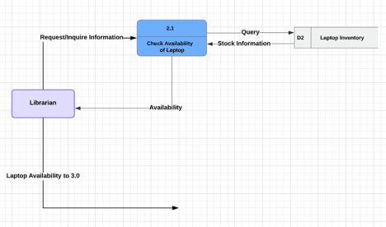

**Sub-processes**

2.1 Check Availability of Laptop - In this subprocess, the librarian will check the availability of the laptop by entering a query into the database “Laptop Inventory”, and will retrieve the stock information.

**Data Flow**

* Request/Inquire Information: Information processed to see availability of laptops
* Query: The data store will be given a query to check availability.
* Stock Information: The availability/unavailability will be confirmed
* Availability: The availability information will be sent to the librarian
* Laptop Availability to 3.0: The laptop availability information will go to the next process.

**External Entities:**

**Librarian:** The librarian will receive the notification about the laptop request.

**Data store:**

**Laptop inventory:** The laptop inventory holds the laptop information along with the total number of laptop quantity available in the laptop inventory.

**Level 3 Diagram**

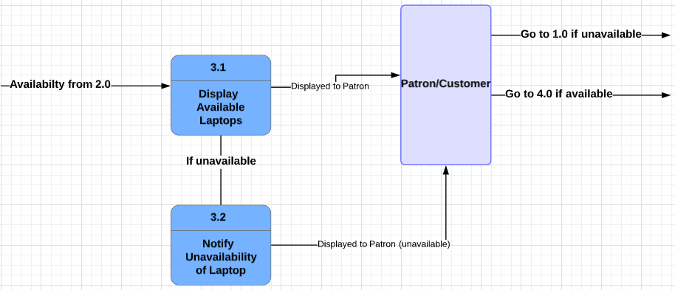

**Sub-Processes**

3.1 Display Availability of Laptops - In this sub-process, the availability of the laptop will be displayed for the patron

3.2 Notify Unavailability of Laptop - In this sub-process, the unavailability of the laptops will be displayed for the patron.

**Data Flow**

* Availability from 2.0: The availability information the previous DFD will be processed.
* If unavailable: The laptop is unavailable.
* Displayed to Patron: The availability information will be displayed to the patron.
* Displayed to Patron (Unavailable): The laptop is not available for the patron.
* Go to 1.0 if unavailable: The user has to choose another laptop.
* Go to 4.0 if available: The user goes to the next process.

**External Entities:**

**Patron/customer:** After querying the available laptops,the availability of laptops will be displayed to the patron.

**Level 4 Diagram**

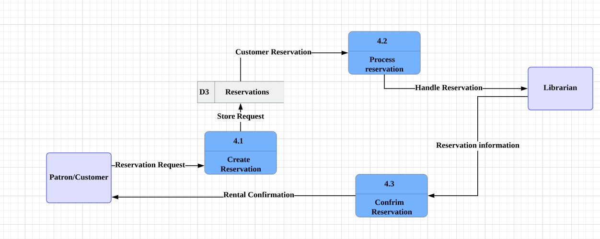

**Sub-Processes**

4.1 Process Reservation- In this sub-process, the reservations will be made by the patron and will be stored in D3: “Reservations”.

4.2 Process Reservation- In this sub-process, the customer reservation will be taken from the datastore D3: “Reservations” and will be handled by the librarian.

4.3 Confirm Reservation- In this sub-process, The librarian will confirm the reservation and will send a confirmation message to the patron.

**Data Flow**

* Reservation Request: The reservation is made by the patron.
* Store Request: The reservation request will be stored.
* Customer Reservation: The customer reservation will be processed.
* Handle Reservation: The librarian will handle the process of the reservation.
* Reservation Information: The reservation will be confirmed by the librarian.
* Rental Confirmation: The confirmation will be sent to the patron

**External Entities:**

**Patron:**The reservation request is made by the patron.

**Librarian:** The reservation request made by the patron will be processed by the librarian.

**Data store**

**Reservations:**

The reservations stores all the laptop reservations made by the patron.

**Level 5 Diagram**

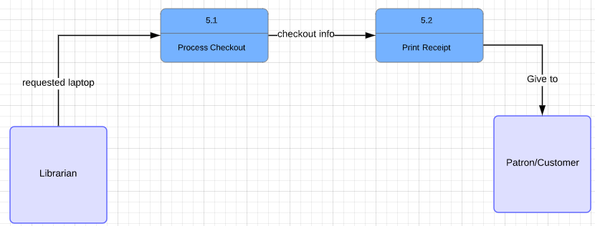

**Sub-Processes**

5.1. Process Checkout - In this sub-process, the librarian will take the requested laptop and begin the checkout process.

5.2. Print Receipt -In this sub-process, the librarian will print out the checkout receipt using the checkout info from sub-process 5.1. Receipt will be given to patrons.

**Data Flow**

* Requested Laptop: The librarian will put the requested laptop through the checkout process.
* Checkout Information: The checkout information will be used for printing out the receipt.
* Give to: The receipt will be given to the patron.

**External Entities:**

**Librarian:** The librarian processes the checkout of the laptop.

**Patron:**The patron will receive the checkout receipt after successful checkout.

**Level 6 Diagram**

**Sub-Processes**

6.1. Process Return - In this subprocess, the librarian will take the laptop returned from the Patron and will check for damages

6.2 Return Failed - In this subprocess, the librarian has checked the returned laptop and there were damages. This laptop return has failed and will be given back to the patron

6.2.1 Fine Incurred - In this subprocess, the fine for damaging the laptop will be given to the patron

6.3 Return Successful - In this subprocess, the laptop returned by the patron was not damaged so the return was successful.

**Data Flow**

* Return Laptop: The patron returns the laptop to the librarian.
* Laptop Information: The laptop is being checked for damages.
* If Damaged: The laptop is damaged
* Not Damaged: The laptop is not damaged and the return will be processed.
* Laptop Damage Information: The laptop is received but there is fines on the patron’s account due to damages caused on the laptop.
* Notify Patron of Fine: Notify patron of fines they incurred from damaged laptop.
* Confirm Return: Notify the patron that the return is successful.

**External Entities:**

**Patron/Customer:** The patron receives the notification of the return or any due fines.

**Librarian:** The librarian processes the return made by the patron.

**Revision of requirement specification and use cases:**

We have made several changes to the requirement specification and use cases as per the DFD diagram. As per the DFD diagram, we have added make reservation, check laptop inventory, and notify patron of availability of laptops. In order to process the laptop requests, the user will be directed to enter the username and password. Similarly, we have added make reservation to process reservation request from the patron.

First Use Case: Request for Laptop

|  |  |
| --- | --- |
| **ID:** | **UCX-1** |
| **Title:** | Process Laptop Request |
| **Description:** | The patron will request a loanable laptop either through the mobile app or through the browser or simply by visiting the Circulation Desk in person. |
| **Actor:** | Primary,Patron who is requesting laptop, Secondary: Laptop Loan Mobile App |
| **Preconditions:** | The patron has no other loanable laptop in their possession and/or patron has a fine |
| **Postconditions:** | If precondition is violated, patron must return the loanable laptop and/or pay a fine. |
| **Main Steps:** | 1. User requests laptop. 2. The system asks for login information. 3. User enters login information. 4. The user submits the request. 5. The system sends notification about availability. 6. User will go to “Reserve a laptop” tab 7. User Reserves a laptop of their choice 8. User will then go to the Circulation desk to pick up a laptop |
| **Exception:** | E1: User already is borrowing a laptop   1. The system will display that “User is already borrowing a laptop” 2. The system will prompt the user to return the laptop   E2: Unpaid balance   1. The system will display that “There is an unpaid balance due” 2. The system will ask the user if it wants to pay the balance |
| **Frequency of Use:** | This would be used very often because requesting a laptop is the main interaction that the user has with the system. |
| **Special Requirement:** | The patron must comply with the library policy and laptop loaning programme. |
| **Priority:** | High priority |

Second Use Case: Check Laptop Inventory

|  |  |
| --- | --- |
| **ID:** | **UCX-2** |
| **Title:** | Check Laptop inventory |
| **Description:** | After receiving the laptop request, the librarian will check the inventory for availability of laptops.So, the query will be processed against the datastore Laptop inventory. |
| **Actor:** | Primary,Patron who is requesting laptop, Secondary the librarian. |
| **Preconditions:** | The librarian received the request for loanable laptop from its patron. |
| **Postconditions:** | The availability of the laptops will be displayed to the user. |
| **Main Steps:** | 1. The librarian checks for the availability of laptop. 2. The laptop inventory provides list of available laptops. |
| **Exception:** | E1: The system is down and unable to provide requested information. |
| **Frequency of Use:** | This would be used very often because requesting a laptop is the main interaction that the user has with the system. |
| **Special Requirement:** | The database must be updated correctly in order to provide accurate information. |
| **Priority:** | High priority |

Third use case: Notify patron of laptop availability

|  |  |
| --- | --- |
| **ID:** | **UCX-3** |
| **Title:** | Notify patron of laptop availability. |
| **Description:** | The patron request a loanable laptop and the request will be processed against the database and the availability of the laptops will be provided to the requested user. |
| **Actor:** | Primary: The librarian. Secondary: ThePatron |
| **Preconditions:** | The server and the database is up to date. |
| **Postconditions:** | The lists of availability laptops are displayed to the user. |
| **Main Steps:** | 1. User requests laptop. 2. The system asks for login information. 3. User enters login information. 4. The user submits the request. 5. The system checks the inventory. 6. The system sends notification to the user about the availability of laptops. |
| **Exception:** | E1: The system is down or the database is not up to date. |
| **Frequency of Use:** | This would be used very often. |
| **Special Requirement:** | The patron must be a registered user and must comply with the library policy and laptop loaning programme. |
| **Priority:** | High priority |

Fourth use case: Make reservation

|  |  |
| --- | --- |
| **ID:** | **UCX-4** |
| **Title:** | Make reservation |
| **Description:** | The patron makes the reservation request after knowing the availability of laptops through the system. |
| **Actor:** | Primary,Patron who is making reservation, Secondary: The librarian. |
| **Preconditions:** | The laptops should be available in order to process for a reservation. |
| **Postconditions:** | The patron successfully reserves the laptop. |
| **Main Steps:** | 1. User chooses the laptop. 2. The user makes reservation requests. 3. The system creates the reservation for the user. 4. The system sends the reservation confirmation to the user. |
| **Exception:** | E1: The server is down.  E2: The user has already an existing reservation. |
| **Frequency of Use:** | This would be used very often because the user can make a reservation using this system.. |
| **Special Requirement:** | The patron should comply with the library policy and the laptop loaning programme. |
| **Priority:** | High priority |

#### Fifth Use Case: Check Out

|  |  |
| --- | --- |
| **ID:** | UCX-5 |
| **Title:** | Check Out Laptop |
| **Description:** | The library user scans the student id. The system validates the id and prompts the user to scan the laptop and the charger. The system records all the information and prints the checkout slip. |
| **Actor:** | Library user |
| **Preconditions:** | 1. The student must have a valid student id. 2. The library has to have a laptop for checkout. |
| **Postconditions:** | 1. The system displays “check out successful” message. 2. The system updates the actions in database. |
| **Main steps** | 1. The library user scans the student id. 2. The system validates and authorize the student id. 3. The library user selects the requested laptop. 4. The library user scans the laptop and the charger. 5. The system records all the information and prompts the user to print out the check out slip. 6. The system displays “check out successful” message. 7. The system sends the checkout receipt to the patron |
| **Special requirements** | The borrower must agree to checkout terms and conditions. |
| **Exception:** | E1: Invalid Student id   1. The system prompts the user to have a valid student id.   E2: Unpaid balance/fine   1. The system displays unpaid balance or fines and prompts the user to collect unpaid balance/fines. |
| **Frequency of Use:** | It is used often as the student can checkout laptops upon availability. |
| **Priority:** | High |

#### 

#### 

#### Sixth Case: Return

|  |  |
| --- | --- |
| **ID:** | UCX-6 |
| **Title:** | Return |
| **Description:** | The library user scans the student id. The system validates the id and prompts the user to scan the loaned laptop and the charger associated with it. The library staff manually perform the checks to ensure that the laptop and charger is in a good condition. If it is not in good condition, the patron will be fined according to the policy set out by the library. |
| **Actor:** | The patron who initiates the return. |
| **Preconditions:** | 1. The laptop should be in good condition without internal/external damage. |
| **Postconditions:** | 1. The return is completed successfully. 2. The action is recorded in the database. 3. The patron receives the return confirmation notification. |
| **Main steps** | 1. The library user scans the student id. 2. The system validates and authorize the student id. 3. The library user scans laptop and the charger. 4. The library staff manually checks the condition of the laptop and the charger. 5. The systems displays “return complete” message and sends notification to the borrower. |
| **Special Requirements:** | The system initiates the return if pre-conditions are satisfied. |
| **Exception:** | E1: The patron damages the laptop. |
| **Frequency of Use:** | Very often. |
| **Priority:** | High |

### 

### Kanban Board

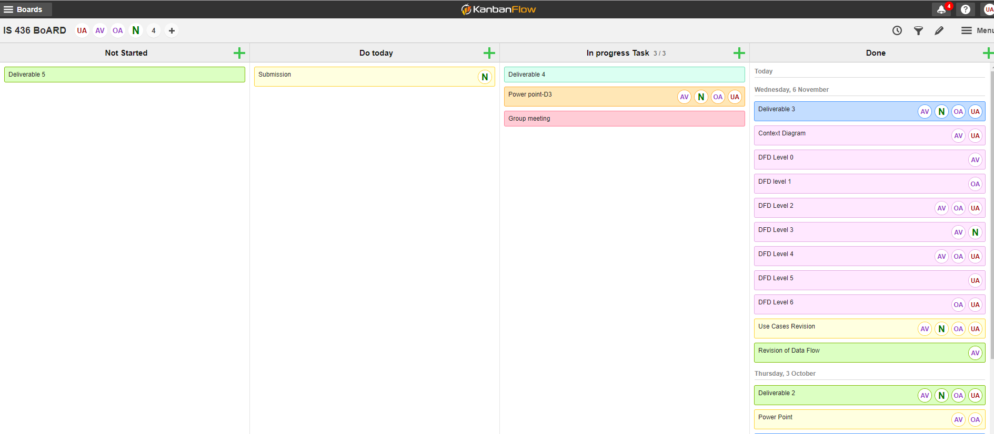

### Project Plan:

